Editorial
In this second issue of the New Educations Newsletter aimed at teachers, educationalists, teacher trainers, policy makers, parents, pupils, and all involved or interested in the New Educations concept. In this issue, we present the Turkish project partner Manisa Sosyal Bilimler Lisesi, we give an update on the status of the modules that were implemented in 2017 so far, we report on the project management meeting in Parma and the training activity that took place in Barcelona. Finally, some short news items about dissemination on “Education for democracy” module was held at “Henri Coanda” Highschool and about World Teachers’ Day celebrated on October 5th in Ghindeni School, Romania.
Stay in touch, subscribe to the newsletter by sending an email to news@new-educations.eu . Also, when you have interesting news to tell us or news that you think is relevant to the New Educations Project, please let us know and we will publish it in this newsletter. We hope you will enjoy the read, let us know what you think! You can also follow the project on social media, join the Facebook group: https://www.facebook.com/TheNewEducations/

About New Educations

Partner in the Spotlight: Manisa Sosyal Bilimler Lisesi
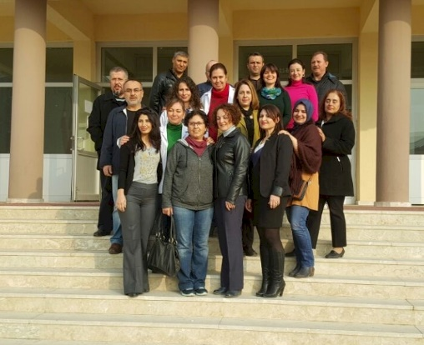
Manisa Sosyal Bilimler Lisesi (Manisa Social Sciences Highschool) is a general state high school with an extra year devoted exclusively to language learning and project work. High school education in Turkey is normally 4 years but our school has a preparatory year which focuses on teaching English and French. Manisa Social Sciences Highschool has 33 staff members and 318 students. The school is only five years old and last year its first students graduated.
The city of Manisa was very famous during the Ottoman Empire for its geographical location. The Sultans of the Ottoman Empire had their first education in Manisa when they were young. The city is surrounded with famous historical and cultural places: the regional metropolitan center of İzmir which is the third biggest city of Turkey. Manisa is also very close to Ephesus and Sardes which are touristic centres. Modern Manisa is a booming center of industry and services, and developing so rapidly and these days it is known as the city of opportunities.
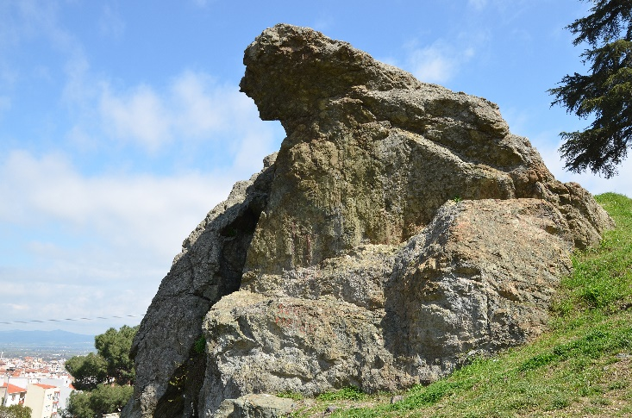
The historic part of Manisa is known for Niobe's "Weeping Rock" ("Ağlayan Kaya"), an ancient bridge called the "Red Bridge" ("Kırmızı Köprü") as well as to several tombs-shrines in the Turkish style dating back to the Saruhan period (14th century).
The school recruits high potential students who have limited resources: many students come from disadvantaged villages and stay at the school’s boarding house. The school's main focuses are Literature, Maths and Languages. Such schools are recently founded to educate those who will become future leaders of the counties, provinces or the country. Graduates often continue their university education in the fields of international relations, public administration and political sciences to become governors or policy makers.
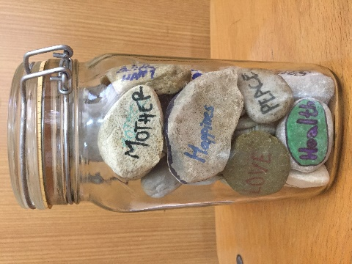
For that reason, the school has been designed according to the norms of the European Union: the focus is for example on citizenship, national and universal values, the ability to analyse individual and social needs and problem solving, collaboration and communication skills, linguistic competences in three languages, project management and policy making. The school provides in that way great opportunities for civic education in diversity.
The school realises many activities with a European perspective: a European Youth Parliament, youth councils, forums, debates, etc. at high school levels within the national Turkish context. The school, its staff and students are open-minded and motivated to share new knowledge and skills.

Project News

Second Project meeting in Parma (Italy)
The Liceo Attilio Bertolucci in Parma (Italy) hosted the second New Educations Transnational Project Meeting from 25 until 27 October 2017. On Wednesday 25th of October the Italian team with Roberta, Silvia, Mara, Maria and colleagues prepared a warm welcome and an interesting programme for the project team at their school. During three intensive days, the project team worked intensively through the agenda, with on the first day working meetings at the Liceo Bertolucci, a job shadowing activity which was very interesting, a visit to the Liceo Musical and finally a sightseeing tour of the old and beautiful town of Parma.
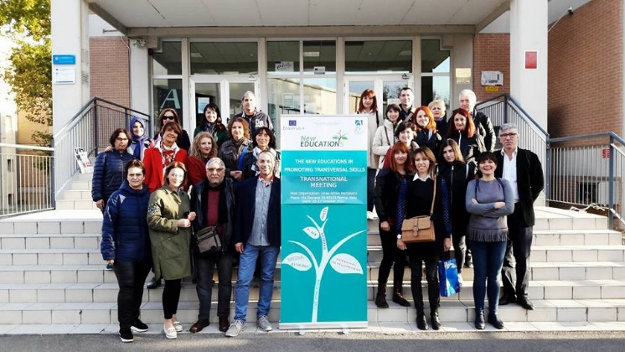
On the second day, the team visited the Cheese Factory of Parmigiano Reggiano before they had a day long management session back at the Liceo Bertolucci as well as an interview with the local press. The final day was spent on a visit to Ligure Riviera, to the historical towns of Portofino and Santa Margherita Ligure. The three days were an excellent occasion for team building and working on the development and management issues of the project.

More workshops: Education for Personal Development and Entrepreneurial Skills
The New Educations Project is about half way through its lifetime and the results are becoming available: already 5 modules with learning and teaching materials are now drafted and tested in the partner schools, they contain the modules for education for peace, for development, entrepreneurial education, education for democracy and civic education. All partner schools have received the guidelines and have been involved in selecting and teaching the lessons according to the scenarios drafted by the partners.
Throughout the first half of 2017 hundreds of pupils from all schools in the project participated in various workshops and activities focused on the acquisition of values, skills and knowledge needed to develop individual personality as well as entrepreneurial skills. The activities have been devised and adapted specifically for this project by a varied group of experts, lead by teachers from Liceum Ogolnoksztalcace w Wieliczce (Poland) and Liceul Tehnologic de Transporturi Auto (Romania).
Entrepreneurial education is a component of the culture and an important domain which helps the future graduates to enter the social and professional life. Entrepreneurial education requires a complex approach: it addresses economic and social problems. This module has a practical character because it involves the development of specific skills that students can use in their day by day life. Teaching and learning activities are required to be centred on students’ interests and to rely on economic reality.
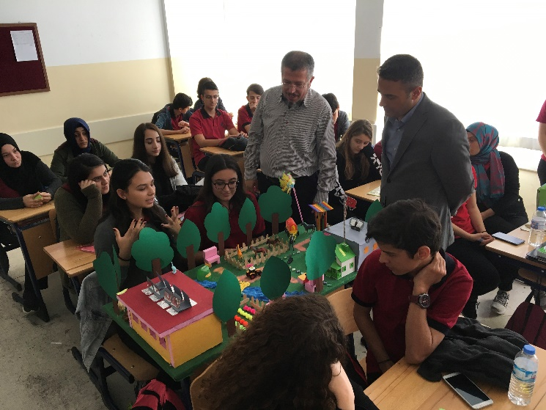
Entrepreneurial education aims to provide skills, knowledge and motivation in order to encourage the students to engage themselves in entrepreneurial activities which provides them success in a variety of directions. At the moment, entrepreneurship is offered under a variety of forms, at all levels of schooling, from lower or upper secondary level to university programs.
Entrepreneurial education is distinguished from other forms of education because it focuses on the reaction opportunities, while management education is focused on the best way to operate existing structures. In both approaches, the interest is the same, namely production of "profit" in any form (for non-profit organizations government, it may take the form either of increasing services, either reduce costs or increase capacity to respond to requests customers or citizens).
The five main themes of the Education for entrepreneurship module are: Labour motivation, Choosing the professional path, Resources, Production cycle of goods, Product promotions, Starting and running a business and Market’s forms. Within each theme, several workshops and subsequent activities have been held in Turkey, Croatia, Romania, Poland and Italy involving hundreds of learners and students.
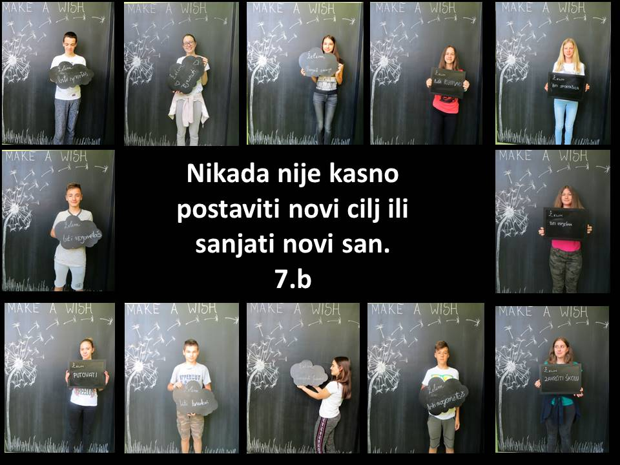
The outcomes of these activities and workshops is put in various forms: brochures, newsletters, pamphlets, posters, photographs, video diaries, questionnaires, etc. Both course modules will soon be made available in the Course Guide on the web site. The draft Methodological Guide, a guide of good practices, that bundles these learning and teaching materials is currently under review. This Guide contains the necessary methodological guidelines for activities for each of those theme as well as examples of good implementation. In this guide, the project demonstrates also the importance of each education for developing transversal skills to students. At the end of the project, the Guide will be published and it will be made available from this web site.

Staff training in Barcelona (Spain)
From Monday 18 until Friday 22 September 2017, DEMÀ (Departament d'Estudis dels Medis Actuals) organised a training seminar on the subject of education for democracy in Barcelona. The training week coincided with the developments of events around the Catalan independence, which made it all even more interesting and relevant. The training programme consisted of lectures, visits, workshops and excursions.
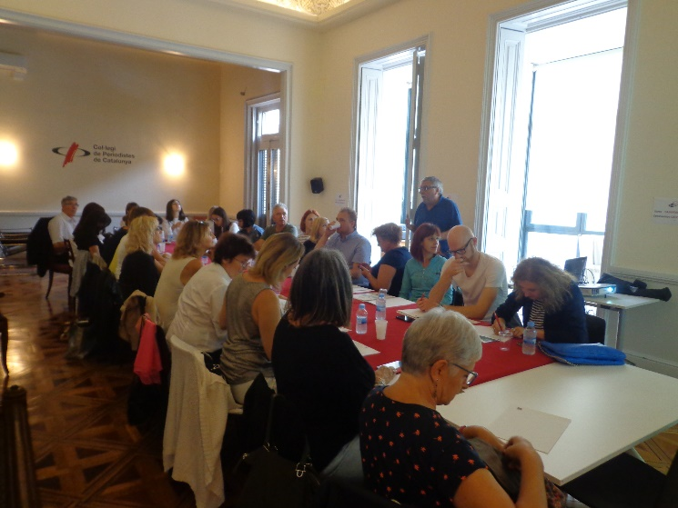
On Monday we visited the Colegi de Periodistes de Catalunya for an interactive introductory workshop entitled “What is democracy? How to define democracy?”. In the afternoon, we went on a guided visit to places of significant interest related to democracy in Barcelona. On Tuesday, we met representatives of the town of l’Hospitalet de Llobregat (the second town of Catalonia) in the City Hall of l’Hospitalet de Llobregat. There we attended a presentation about the rules of City Councils in larger cities and a presentation and workshop around the methodology of the City’s learning services and projects. Lunch took place in the adult education centre “El Llindar” in l’Hospitalet de Llobregat. The afternoon concluded with a visit to the historical “Can Riera”, a memorial centre of the City of l’Hospitalet de Llobregat.
On Wednesday, we were received at Palau Macaya for an intensive workshop about Media and Democracy with Professor Xavier Giró, Director of the Observatory of Conflict and Professor at the Autonomous University of Barcelona. In the afternoon, a visit to the Museum of History of Catalonia was planned.
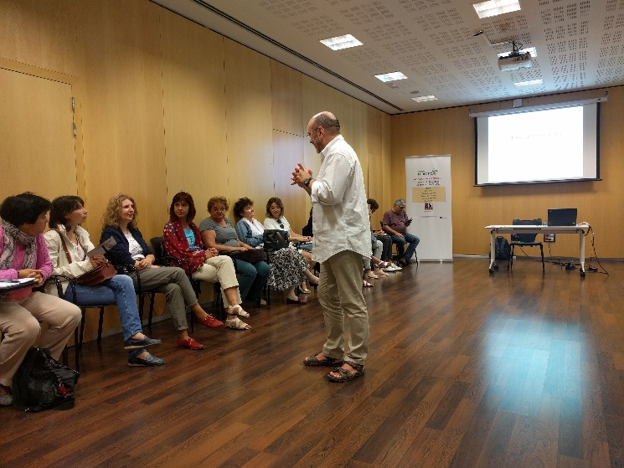
On Thursday we visited the IES Bellvitge, Institute of Secondary Education for a workshop on democracy and diversity. On the final day of this intense training week, we had an open discussion about the methods of education for democracy at the Palau Macaya. In the afternoon, we visited the Parlament de Catalunya. The training week closed with the farewell dinner and the certificates ceremony.
It was a week to remember for many reasons.

Project Dissemination News
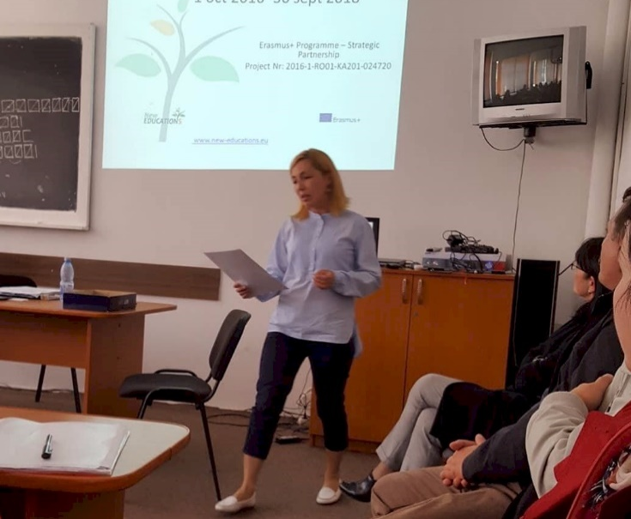
A dissemination on “Education for democracy” module was held at “Henri Coanda” Highschool on the 2nd of October by English teacher Sonia Dobre. It was attended by 50 people. The idea of the project, the objectives and the outcomes were presented, then the meeting in Barcelona. This was followed by an interactive workshop, in which all the participants were involved. The workshop was inspired by one of the “Education for personal development” themes - “It’s better to be a rainbow”, and its purpose was to give the participants a clear and helpful insight on the “New Educations” concept.
This activity was not only a great success for all participants, but it also raised interest in the themes, modules and the intellectual outputs of the project.
World Teachers’ Day was celebrated on October 5th in Ghindeni School, Romania, by teachers and students who participated in a series of workshops on how education and teachers make a difference in the classroom and beyond. This year’s theme was “Empowering Teachers, investing in the future”.
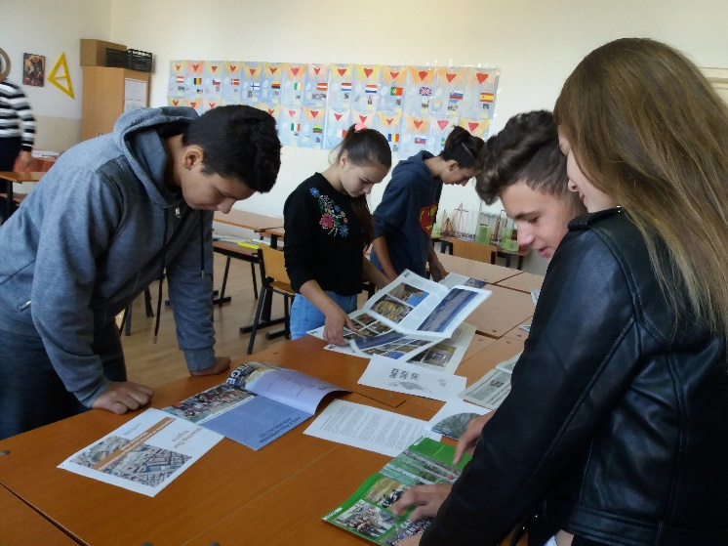
As the seminar on Democracy held by D.E.M.A had a strong impact on the participant teachers, we integrated the subject of democratic school in these activities. The aim of World Teachers' Day is to provide an opportunity to consider issues related to teachers and teaching.

Editorial Notes
For more information, to submit content or to unsubscribe from this newsletter, please contact the New Educations Editorial Team: news@new-educations.eu .

The European Commission support for the production of this publication does not constitute an endorsement of the contents which reflects the views only of the authors, and the Commission cannot be held responsible for any use which may be made of the information contained therein.

